Surviving the Senior Year

A Guide for
Juniors and Seniors


Paulding County School District
Counseling Department

The purpose of this handbook is to help juniors and seniors as well as their parents understand the career decision-making process and explore the options available during the senior year and after high school. Every student is College and Career Ready!

JUNIORS and SENIORS!

Welcome “Upperclassmen”! Your last two years of high school are filled with great opportunities, challenging academic classes and thoughtful choices. As you end the junior year and continue the senior year, some important topics to keep in mind are:

- Stay focused on academics. Even through you are busy with extracurricular activities and outside jobs, your school work is your priority! Stay focused on academics. Your GPA counts! Oftentimes, your high school transcript is sent with your grades through the end of your junior year--especially when you apply in the fall of your senior year, so STUDY HARD!

- Take rigorous and relevant courses. Challenge yourself with rigorous courses that will be a good foundation for your future and relevant to your educational and career goals.

- Decide on a Pathway. Remember it is important to be a Pathway Completer. You may opt to do that in CTAE, Fine Arts, or World Language. There are also Academic Pathways in which you can be a Pathway Completer.

- Keep an accurate calendar/planner. It is important to be organized. You will need to keep track of many things: testing dates, admission dates, and scholarship deadlines.

- As a senior, you will need to decide what you are going to do after you graduate and prepare for that choice. Whether the post secondary choice is at a university, community college, apprenticeship, or the military, there are steps you must take now to be prepared for entrance.

- Complete career exploration: talk to relatives, job shadow someone in a position you have an interest in, research careers on the Internet. Ask your school counselor for assistance.

- Remember to think about Senior Capstone Project. As you narrow in on a career choice consider the career that will plan, research, write about, acquire a mentor, and make a presentation.

- Continue to develop your hobbies and interests and keep track of the "extras" that you do.

- Research your options for next year.

- Familiarize yourself with where to find scholarship information.

- See your counselor early and often to assist with any questions that you might have.

- Make use of the many resources available to you: this handbook, the Internet, the Career Center, and www. GAfutures.org - GAfutures
Let this handbook be a valuable guide to you!

GRADUATION REQUIREMENTS

High School Diploma Requirements
Areas of Study | Units of Credit |  | Addtl. Information
English/Language Arts*** | 4 units
Mathematics*** | 4 units
Science*** | 4 units
Social Studies*** | 3 units
Health and Physical Education | 1 unit
CTAE and/or World Language and/or Fine Arts | 3 units |  | 2 units of the  same World  Language
General Electives | 4 units
Total Units Required for Graduation | 23 units
***Research, Regional, and State institutions of The University System of Georgia may require additional units in academic core areas in addition to the high school diploma units required.

The following provides the total unit requirements for graduation and the unit requirements for promotion into the next grade level. Students in the district always go to the next level based on their cohort year and the promotion requirements below are minimum requirements.

Graduation Requirements | 23 units
Promotion Requirements | To 10th – 5 units  To 11th – 11 units  To 12th – 17 units

Senior Advisement Checklist for Students

With the right grades, right planning and right steps, you will be college and career ready. For you, college and career ready could mean college/university, technical college, specialty school, military or a skilled job. You can make sure being career ready happens! Two valuable resources are www.GAfutures.org and The College Board’s Big Future www.bigfuture.collegeboard.org websites. Another valuable site is the Georgia Career Information System site: http://www.gcic.peachnet.edu/
Below is a checklist to make certain that you take the right steps and make the right choices for your postsecondary decision:
Month | Senior Advisement To Do List:
August | Think Future! Think about and discuss any college or work setting visits as well as military staff discussions that may be valuable for your career decisions after high school graduation. Use the district Surviving the Senior Year guide. Most importantly use your YouScience results from the ability and interest assessment that you completed last school year.  Use these links to research information:  GAfutures: www.GAfutures.org  Campus Tours: www.campustours.com  College Board: www.bigfuture.collegeboard.org  College Express: www.collegeexpress.com  CollegeNet: www.collegenet.com  Georgia Skilled Trades: http://www.gobuildgeorgia.com/  Military Careers: www.militarycareers.com  Occupational Outlook Handbook: http://www.bls.gov/ooh/
September | Review your grade point average. First semester admissions documents use the grade point average through the junior year. The high school transcript has both a numeric as well as a 4.0 grade point average. Class rank uses the numeric grade point average.  Link for HOPE GPA is under My GAfutures on www.GAfutures.org site.
September | Motivate Yourself! Continue to be sure that you are enrolled in challenging courses. Keep up and do well in these courses. Remember your parent/guardian may use IC Parent Portal for schedule and grade information.
September | Check the HOPE GPA on GAfutures on your My GAfutures account. Remember all academic courses count both required and elective courses including an academic work-based learning course(s). Also remember no middle school academic courses count.  General HOPE Scholarship information may be found on this link:  https://www.gafutures.org/hope-state-aid-programs/  Rigorous course information may be found on this link:  https://www.gafutures.org/media/113414/rigor-course-list-july-2016.pdf  All core courses taken in grades 9-12 are calculated in the HOPE GPA. Again, no middle school courses taken for high school credit are calculated in the HOPE GPA.
September | Meet with your professional school counselor about Dual Enrollment Move on When Ready documents. Seniors involved in Dual Enrollment courses under the Move on When Ready Program must have an advisement conference completed at the beginning of each semester and the appropriate documents completed by the professional school counselor.
September | Narrow the List! Review a list of target post-secondary options and discuss the finalized list of choices based on research completed during junior year. Use GAfutures to compare and contrast Georgia schools both public and private.  Resources:  Surviving the Senior Year district guide
September | Focus on a Career! Think about and discuss the Senior Capstone Project, a career-focused research project with a presentation and career mentor component. Narrow your career choice. Use your YouScience results! Make sure that all applicable information and documents are completed. This project is required in the 16-17 school year at all high schools.
September | Obtain testing schedule for SAT and/or ACT and consider your time line is for test preparation s well as registration.  Link for SAT: www.collegeboard.org  Link of ACT: www.act.org  Test preparation link on GAfutures: https://www.gafutures.org/college-planning/college-decision-guide/test-prep/
September | Participate in BRIDGE (Building Resourceful Individuals to Develop Georgia’s Economy) Senior Advisement and Letter opportunities during Classroom Guidance with your school counselor.
September | Remember, the counselors in the counseling office are available to help YOU! Always contact the counselor regarding any of your questions or concerns.
September | Go to the Fair! Plan to attend PROBE Fair (Explore the Possibilities) in October. Talk with military, technical school and college representatives. Most representatives will be from in-state schools. However, there are also some out-of-state postsecondary institutions represented. Typically, there are 60+ representatives at this valuable event.
September | Again think about registering for the SAT and/or ACT.  Link for SAT: www.collegeboard.org  Link of ACT: www.act.org  Test preparation link on GAfutures: https://www.gafutures.org/college-planning/college-decision-guide/test-prep/
October | Attend the PROBE Fair held in early October at one of the district high schools. Location is announced during August.
October | Take a Trip! Make plans to attend a campus or campuses that you were not able to attend last year or last summer. Oftentimes, this visit provides you with valuable information to make a final decision.
October | Attend along with your parent/guardian the mandated by Georgia law, BRIDGE Advisement session at the high school. Your Senior Letter is finalized during this event. Page 2 of the Senior Letter lists all graduation requirements that are still outstanding. Valuable information is presented during this opportunity and is the second part of the Senior Seminar experience with the first opportunity being classroom guidance by the school counselor with seniors.
October | Stay Calendar Coordinated! Be organized and put together a calendar of important “things to do”. This calendar should include SAT/ACT testing dates as well as early admission, application, scholarship, and financial aid information deadlines.
October | Identify colleges, universities, and/or technical schools in which you are interested. Use GAfututes information to compare and contrast at least 3 different postsecondary options, if this process was not finalized in August.
October | Check on the identification of a specialty school, work or the military if you are not interested in attending a post-secondary institution.  Georgia Skilled Trades Link: http://www.gobuildgeorgia.com/  Military Careers Link: www.militarycareers.com  Occupational Outlook Handbook Link: http://www.bls.gov/ooh/
October | Use the www.GAfutures.org website for online application in the state of Georgia. Make certain you obtain additional application and admission procedures via online websites for individual postsecondary institution(s) both in and out-of-state.
October | Think about the "Senior Survival" presentation during classroom guidance. Be sure to review the Surviving the Senior Year guide. This guide has important information as well as a glossary of terms. It is linked to the district counseling department website.
October | Explore scholarship, grant and financial aid options. Website resources are listed toward the back of the Surviving the Senior Year guide. Begin this process early as scholarship deadlines are staggered throughout the senior year.
October | Think Scholarships! Make sure you have a good grasp on local scholarships as well as researching a possible list of scholarships that you will apply for this school year. Research scholarships that are unique to the postsecondary institution you may attend. School counselors have local scholarship information. Helpful links are:  GAfutures Financial Aid and Scholarships: https://www.gafutures.org/federal-aid-scholarships/  FastWeb - www.fastweb.com
October | Double check NCAA Clearinghouse certification applications, if you intend to participate in college athletics. Remember the only online courses approved by NCAA are those completed via Georgia Virtual School.  Link for NCAA Eligibility Center: http://web1.ncaa.org/ECWR2/NCAA_EMS/NCAA.jsp
October | Register for the SAT and/or ACT. Use test preparation materials.  Link for SAT: www.collegeboard.org  Link of ACT: www.act.org  Test preparation link on GAfutures: https://www.gafutures.org/college-planning/college-decision-guide/test-prep/
November | Be sure you are maintaining an organized calendar of important dates.
November | Keep Talking! See your counselor and discuss applying to schools with early admission application deadlines. Some of these deadlines occur this month and may have already occurred for some schools earlier in the fall semester. If a letter or letters of recommendation by teachers or counselors is a requirement, make sure you are asking about these being completed well ahead of the deadline, 3 weeks ahead is recommended.
November | Check on the mailing of ROTC and military academy applications, if applicable.
November | Consider registering for and taking COMPASS, if applicable. This test is needed for technical schools.
November | Take the SAT and/or ACT, if needed. Use test preparation materials as needed.  Link for SAT: www.collegeboard.org  Link of ACT: www.act.org  Test preparation link on GAfutures: https://www.gafutures.org/college-planning/college-decision-guide/test-prep/
December | Think $! Communicate with the Financial Aid offices of the postsecondary school(s) that you are interested in, requesting information about financial aid and scholarships.
December | Participate in Apply to College Week/Month at the high school. Counselors guide you through this process.
December | Think about the ASVAB test. This is an optional test provided at the high school. The Armed Services Vocational Aptitude Battery is a very widely used multiple-aptitude test battery. As an aptitude test, the ASVAB measures your strengths, weaknesses, and potential for future success. The ASVAB also provides valuable career information for various civilian and military occupations and is an indicator for success in future endeavors whether you choose to go to college, technical college, or a military career.  Link: http://www.military.com/join-armed-forces/asvab
December | Keep a file of all information and correspondence--emails and/or regular mail to postsecondary institutions.
December | Participate in the College and Career Fair held at Paulding County High School. This is an additional opportunity after the PROBE Fair that was held in the fall to meet with college, university and technical college admissions representatives. Military representatives are also present.
December | Meet with the professional school counselor in early December about Dual Enrollment/College Credit Now documents. If you are involved with Dual Enrollment courses you must have an advisement conference completed at the beginning of each semester and the appropriate documents completed.
December | Make plans to attend the Financial Aid night held in January at the high school.
January | Attend Financial Aid night with your parent/guardian. At this event you and your parent/guardian will learn more about the Free Application for Federal Student Aid (FAFSA). This document must be completed for all students and their parents who apply for federal student aid to help pay for college. It is important to submit the FAFSA as soon after January as possible. The FAFSA completion is also a requirement to be awarded the HOPE Scholarship.  Website is: www.fafsa.ed.gov  Review SAR (Student Aid Report) after the completion of the FAFSA.  Additional resources:  GAfutures - https://www.gafutures.org/federal-aid-scholarships/  College Aid - www.collegeaid.net  Direct Loan - www.ed.gov/offices/OPE/DirectLoan  FastWeb - www.fastweb.com  Georgia Student Finance Commission Financial Aid - www.gsfc.org  Financial Aid Estimator - www.nasfaa.org/Home.asp
January | Monitor your HOPE GPA via your My GAfutures account. Continue to work hard and take challenging courses. Both final admissions and scholarship eligibility are dependent on final, second semester grades.  General HOPE Scholarship information may be found on this link:  https://www.gafutures.org/hope-state-aid-programs/  Rigorous course information may be found on this link:  https://www.gafutures.org/media/113414/rigor-course-list-july-2016.pdf  All core courses taken in grades 9-12 are calculated in the HOPE GPA. No middle school courses taken for high school credit are calculated in the HOPE GPA.
January | How is your progress on your Capstone Project.
February | Double check NCAA Clearinghouse certification applications, if you intends to participate in college athletics. Remember the only online courses approved by NCAA for district students are via Georgia Virtual School courses.  Link for NCAA Eligibility Center: https://web3.ncaa.org/ecwr3/
March | Make a Decision! You may still be undecided about the future. For additional assistance make an appointment with the school counselor.  Georgia Skilled Trades Link: http://www.gobuildgeorgia.com/  Military Careers Link: www.militarycareers.com  Occupational Outlook Handbook Link: http://www.bls.gov/ooh/
March | Talk Finances! Think about looking for summer employment and talk about a budget for summer and for next year with parent/guardian.
April | Remember if you are taking Advanced Placement courses, prepare for the AP exam.
April | Follow through with the finalization of your Senior Capstone project, if applicable for your high school.
April | Make sure that required deposit(s) are paid by the deadlines, if you are attending an institution that requires deposits for enrollment and/or room and board.
May/June | Ask any questions that you still have about Advanced Placement exams, if applicable.
May/June | Attend awards night and of course, graduation.
May/June | Remember to thank the school personnel who have helped you.
May/June | Make certain you request that a final high school transcript be sent to the university, college, or technical school. This request is completed through your GAfutures via your My GAfutures account for in state institutions. Procedures are provided by professional school counselors.
May/June | Check with the admissions and/or financial aid offices at the college, university or technical college to make certain that the staff has everything that is needed.
May/June | Monitor your final HOPE GPA in mid-June via the My GAfutures account. The final, verified GPA with the Georgia Student Finance Commission is used for HOPE Scholarship eligibility as well as Zell Miller Scholarship eligibility.  General HOPE Scholarship information may be found on this link:  https://www.gafutures.org/hope-state-aid-programs/  Rigorous course information may be found on this link:  https://www.gafutures.org/media/113414/rigor-course-list-july-2016.pdf  All core courses taken in grades 9-12 are calculated in the HOPE GPA. No middle school courses taken for high school credit are calculated in the HOPE GPA.
May/June | Look to the Future! Have you registered for summer orientation programs at the technical college, college or university that you will attend in the Fall. For some post secondary schools there is also a parent orientation session on the campus, so that your parent/guardian may learn more about the institution.


Junior Advisement Checklist for Students

With thorough planning and career exploration, you will be ready for your senior year and will make thoughtful college and career ready decisions. You can make sure it happens! Two valuable resources are Gafutures at www.GAfutures.org and The College Board’s Big Future www.bigfuture.collegeboard.org websites. The GCIS website is also utilized. Below is a checklist to make certain that you take the right steps to be successful throughout the rest of high school and makes the right choices for your postsecondary decision:

Month | Advisement To Do Checklist:
August | Review your grade point average. Your GPA counts. It is the GPA at the end of the junior year that is used for most college applications in the fall of the Senior year. The high school transcript has both a numeric as well as a 4.0 grade point average. Class rank uses the numeric grade point average.  Link for HOPE GPA is under My GAfutures on www.GAfutures.org site.
August | Check the HOPE GPA on GAfutures on your My GAfutures account. Remember all academic courses count both required and elective courses including an academic work-based learning course(s). Also remember no middle school academic courses count.  General HOPE Scholarship information may be found on this link:  https://www.gafutures.org/hope-state-aid-programs/  Rigorous course information may be found on this link:  https://www.gafutures.org/media/113414/rigor-course-list-july-2016.pdf  General All core courses taken in grades 9-12 are calculated in the HOPE GPA. Again, no middle school courses taken for high school credit are calculated in the HOPE GPA.
August | Motivate! Encourage yourself to be enrolled in challenging courses as well as pathway courses of interest in one or more of these areas: Career, Technical and Agricultural Education, Fine Arts, World Language or Advanced Academic Pathways in English, Mathematics, Science or Social Studies.
August | Meet with the professional school counselor about Dual Enrollment MOWR program and required documents, if applicable. Juniors involved in Dual Enrollment courses must have an advisement conference completed at the beginning of each semester and the appropriate documents completed by the professional school counselor.
August | Keep Researching! Make a preliminary list of target post-secondary options. Use these resources:  Surviving the Senior Year district guide  Link for GAfutures College Search: https://www.gafutures.org/college-search
August | Obtain testing schedule for SAT and/or ACT and consider plans to take test as well as what your time line is for test preparation.  Link for SAT: www.collegeboard.org  Link of ACT: www.act.org  Test preparation link on GAfutures: https://www.gafutures.org/college-planning/college-decision-guide/test-prep/
August | Remember, the counselors in the counseling office are available to help you. Contact the counselor regarding any of your questions or concerns.
August | Go to the Fair! Plan to attend PROBE Fair (Explore the Possibilities). Talk with military, technical school and college representatives. Most representatives will be from in-state schools. However, there are also some out-of-state postsecondary institutions represented. Typically, there are 60+ representatives at this valuable event.
September | Attend the PROBE Fair held at one of the district high schools. Location is announced during August.
September | Plan, Prepare and Plan Some More! Consider any college and/or career exploration information that may be valuable for you in making career decisions after high school graduation. Use the district Surviving the Senior Year guide. Use these links to research information:  GAfutures: www.gafutures.org  Skilled Trades: http://www.gobuildgeorgia.com/  Military Careers: www.militarycareers.com  Occupational Outlook Handbook: http://www.bls.gov/ooh/  US Department of Labor Career Search: http://www.mynextmove.org/
September | Think about how course work is going including any major project deadlines.
September | Build Credentials! Begin or continue to be involved in extra-curricular activities. Think about what you have learned from these experiences especially in identifying personal abilities, aptitudes and interests.
September | Review the PSAT/NMSQT bulletin and determine if you are going to take the PSAT this year. This test is needed to qualify for National Merit Scholarships for the senior year. There is a cost for this test.  Link: http://www.collegeboard.com/student/testing/psat/about/bulletin.html
September | Think about the Georgia High School Graduation Writing test, a graduation requirement.
September | Consider Dual Enrollment/College Credit Now options for second semester or for the senior year, if applicable. As questions arise, talk with your counselor.
September | Check NCAA Clearinghouse information, if applicable. Remember the only online courses approved by NCAA are those completed via Georgia Virtual School. Seek help from your professional school counselor, if needed.  Link for NCAA Eligibility Center: https://web3.ncaa.org/ecwr3/
September | Again think registration for the SAT and/or ACT. Use test preparation materials.  Link for SAT: www.collegeboard.org  Link of ACT: www.act.org  Test preparation link on GAfutures: https://www.gafutures.org/college-planning/college-decision-guide/test-prep/
October | Once again will you be taking the Preliminary SAT/National Merit Scholarship Qualifying Test (PSAT/NMSQT). A junior must take the test in 11th grade to qualify for scholarships and programs associated with the National Merit Scholarship Program. This test is always in mid-October.  Link for PSAT: http://www.collegeboard.com/student/testing/psat/about.html
October | Explore Options! Begin to identify college and/or technical schools in which you are interested. As part of the BRIDGE advisement process during first semester, you will select three postsecondary institutions. This activity is required by Georgia BRIDGE law.
October | Take the YouScience Ability and Interest assessment very seriously. The results are amazing!!
October | Take the SAT and/or ACT, if needed. Use test preparation materials as needed.  Link for SAT: www.collegeboard.org  Link of ACT: www.act.org  Test preparation link on GAfutures: https://www.gafutures.org/college-planning/college-decision-guide/test-prep/
November | Update your Individual Graduation Plan in GCIS. It is a BRIDGE Law requirement that the parent review and approve this plan. The BRIDGE advisement opportunity occurs in either January or February at the high school.
November | Discuss with parent/guardian the updating of your GCIS portfolio with your top 3 postsecondary institutions. Counselors assist with this. This is a good time to take another career interest inventory if a career choice and postsecondary plans are still undecided.
November | Meet with the professional school counselor in early December about Dual Enrollment Move On When Ready program information and documents. If you are involved in Dual Enrollment courses, you must have an advisement conference completed at the beginning of each semester and the appropriate documents completed.
November | Consider the ASVAB test. This is an optional test provided at the high school. The Armed Services Vocational Aptitude Battery is a very widely used multiple-aptitude test battery. As an aptitude test, the ASVAB measures your strengths, weaknesses, and potential for future success. The ASVAB also provides valuable career information for various civilian and military occupations and is an indicator for success in future endeavors whether you opt to go to college, vocational school, or a military career.  Link: http://www.military.com/join-armed-forces/asvab
December | Plan to attend the mandated by Georgia law, BRIDGE Advisement session at the high school. Your BRIDGE graduation plan also known as the Individual Graduation plan in GCIS is updated. Valuable information is presented during this opportunity. Again, this event is typically held at the high school in January or February.
December | Participate in the College and Career Fair held at Paulding County High School. This is an additional opportunity after the PROBE Fair that was held earlier in the Fall semester to meet with college, university and technical college admissions representatives. Military representatives are also present.
December | Think Money! Make plans to attend the Financial Aid night held in January at the high school. Of course, this opportunity will be held again during the senior year. This is also a good opportunity to discuss budgeting.
December | Think about the option of testing-out of up to three EOC courses. The school district website along with school counselors have information during December, January and early February should you have questions.
January | Review your PSAT results, if you took the test in October. Counselors typically provide score results to juniors in early January. If you need some assistance in understanding the results, the counselor has The College Board Power Point that can be shared with you.
January | Attend the BRIDGE Advisement opportunity at the high school. Review the Career Planner, a district planning guide Link is http://www.paulding.k12.ga.us/cms/lib010/GA01903603/Centricity/Domain/209/16%2017%20Career%20Planner.pdf  Topics covered during this parent/student event are:  Individual Graduation Plan in GCIS – Required by Georgia Law that a parent/guardian approves the plan. Also, included is the course request information for your student for the senior year.  Dual Enrollment Move on When Ready Program
January | Be certain to complete the Honors/Advanced Placement course request process for next school year.
January | Think Dollars and Cents! Attend Financial Aid night. At this event you will learn more about the Free Application for Federal Student Aid (FAFSA). This document must be completed for all students and their parents who apply for federal student aid to help pay for college. It is important to submit the FAFSA as soon after January as possible. The FAFSA completion is also a requirement to be awarded the HOPE Scholarship.  Website is: www.fafsa.ed.gov  Review SAR (Student Aid Report) after the completion of the FAFSA.  Additional resources:  GAfutures Financial Literacy - https://www.gafutures.org/federal-aid-scholarships/financial-aid-basics/financial-literacy/  College Aid - www.collegeaid.net  Direct Loan - www.ed.gov/offices/OPE/DirectLoan  FastWeb - www.fastweb.com  Georgia Student Finance Commission Financial Aid - www.gsfc.org  Financial Aid Estimator - www.nasfaa.org/Home.asp
January | Monitor your HOPE GPA via your My GAfutures account. Work hard and take challenging courses.  General HOPE Scholarship information may be found on this link:  https://www.gafutures.org/hope-state-aid-programs/  Rigorous course information may be found on this link:  https://www.gafutures.org/media/113414/rigor-course-list-july-2016.pdf  All core courses taken in grades 9-12 are calculated in the HOPE GPA. No middle school courses taken for high school credit are calculated in the HOPE GPA.
January | Think about money needed for college, if that is your career decision after next year.  Link: http://studentaid.ed.gov/sites/default/files/2013-14-do-you-need-money.pdf
February | Consider beginning the scholarship search process.  Link for US Department of Labor Scholarship Search: http://careerinfonet.org/scholarshipsearch/ScholarshipCategory.asp?searchtype=category&nodeid=22
February | Discuss continued research and assembling of colleges/technical/specialty schools. Contact military recruiters, if applicable.  Links:  GAfutures: https://www.gafutures.org/scholarship-search  Georgia Skilled Trades: http://www.gobuildgeorgia.com/  Military Careers: www.militarycareers.com  Peterson’s: http://www.petersons.com/college-search/how-to-choose-a-college.aspx
February | Participate in BRIDGE Graduation Plan updating and reviewing your course requests for the senior year. This is finalized during the BRIDGE advisement process. Use the Career Planner, a district planning guide.  Link is http://www.paulding.k12.ga.us/cms/lib010/GA01903603/Centricity/Domain/209/16%2017%20Career%20Planner.pdf
March | Keep Talking! Talk with parents and others in the career field that you are interested in. Make certain that you have carefully reviewed your YouScience results. For additional assistance make an appointment with the school counselor.  Georgia Skilled Trades Link: http://www.gobuildgeorgia.com/  Military Careers Link: www.militarycareers.com  Occupational Outlook Handbook Link: http://www.bls.gov/ooh/
March | Think about future career plans. If your are making plans to attend a college or university, then, make plans to visit a campus or campuses that you might want to attend during spring break or summer. It is always good to visit one or more colleges or universities when classes are in session, if possible. Oftentimes, this visit provides you with valuable information to make a final decision during your senior year.
April | If you are involved with Advanced Placement courses, think about AP exam preparation.
April | Think $! Review information you learned, if you attended the Financial Aid opportunity at the high school. Explore scholarship opportunities. Use the GAfutures scholarship search website as well as websites provided during classroom guidance by your school counselor.  Link regarding scholarships, grants and loans:  www.fastweb.com  Federal Grant Programs: http://studentaid.ed.gov/sites/default/files/federal-grant-programs.pdf  Scholarships for Military: http://studentaid.ed.gov/sites/default/files/scholarships-for-military.pdf  Do you need money for college?: http://www.edpubs.gov/document/en1158p.pdf?ck=345
April | Take some time to read about scholarship scams:  Links: http://studentaid.ed.gov/types/scams  http://studentaid.ed.gov/sites/default/files/dont-get-scammed.pdf  http://studentaid.ed.gov/sites/default/files/student-aid-and-identity-theft.pdf
May | Make sure you are ready for Advanced Placement exams, if applicable.
May | Ask your parent to register via the school district website if you are interested in taking SB289 Online courses during the senior year. Information is available on the district website during April through mid-July. Students who are not registered by the closing date will not have this opportunity available for the next school year.
May | Discuss plans for taking the SAT and/or ACT, if you decided not to take either of these during the junior year.  Link for SAT: www.collegeboard.org  Link of ACT: www.act.org  Test preparation link on GAfutures: https://www.gafutures.org/college-planning/college-decision-guide/test-prep/
May | Take a Trip or Maybe 2! Visit universities, colleges and/or technical schools based on your career interest over the summer. Select three to five schools.
May | Explore and Research Options! Review college/university/technical college admissions websites and the application process over the summer.
June | Monitor final HOPE GPA in mid-June via your My GAfutures account. The final, verified GPA with the Georgia Student Finance Commission is used for HOPE Scholarship eligibility as well as Zell Miller Scholarship eligibility.  Final verification occurs in June of your senior year after graduation.  General HOPE Scholarship information may be found on this link:  https://www.gafutures.org/hope-state-aid-programs/  Rigorous course information may be found on this link:  https://www.gafutures.org/media/113414/rigor-course-list-july-2016.pdf  All core courses taken in grades 9-12 are calculated in the HOPE GPA. No middle school courses taken for high school credit are calculated in the HOPE GPA.


THE ANSWER: “THE FIVE KEYS to YOUR FUTURE”

You will blink twice and high school graduation will be just
around the corner! Most students don’t realize how fast their
senior year moves along.

There are 5 options to consider after high school. These options
are “gateways” to the future and are listed below:

1. POST-SECONDARY EDUCATION
- 4 year colleges and universities.
- 2 year colleges and community colleges.
- Technical and professional schools and colleges.
- Important reminder for this option--Admissions' staffs look at:
Grades in rigorous courses
SAT and/or ACT results
Class rank
Grades in the academic CORE (English, math, science, social studies,
and world language)
Essays and letters of recommendation, when applicable
Work/school activities

2. MILITARY
- Army.
- Navy.
- Air Force.
- Marine Corps.
- Coast Guard.

3. WORKFORCE
- Full-time permanent jobs.
- Combination of one or more part-time jobs.
- Contract services on short-term basis.

4. APPRENTICESHIP AND INTERNSHIPS
- Carefully monitored work experiences with intentional learning goals.

5. SELF-EMPLOYMENT AND ENTREPRENEURSHIP
- Start a business.
- Buy a business.
- Take on a franchise.
- Consult or freelance.


Selecting a College, Technical
College, Military and College
Together, Other Skills Training,
Work
?????????

There are many factors to consider when choosing a postsecondary school or training. Note the comparison worksheet in this guide. Review this document to help you start thinking about your selection process. Make a list of your top five college and/or technical school choices below and begin comparing (remember to include a school close to home and also include one that is a sure bet for you to be accepted.)
1.
2.
3.
4.
5.

THE QUESTION: WHAT'S NEXT?
Life is full of questions, transitions, and changes. Some questions are relatively easy to answer, such as what to wear or what music to listen to; but answering questions about your future can be somewhat perplexing at times. There are so many things to think about, it's difficult to know where to start. A few of these questions to contemplate are:

- Do I want to go to college? Do I want to learn a skill at a technical school? Do I want to go directly to work? Maybe it isn’t an either/or situation. Maybe I need to think about a combination of choices.

- Will I be happy with a job I can get right out of high school? Do I want a job that
requires more training? Can I get on-the-job training in my career interest area?

- Should I go directly to a four-year college? Should I go to a two year college? How might I feel about transferring after two years, if I attend a two year college?

- Do I want to look only at in-state colleges/technical schools so that I can use the HOPE scholarship, if I qualify for it? Would I like to look at colleges further away?

- Will I go away to college? Will I live at home and commute? How much money might I save, if I made this choice?

- Should I go to work to earn money for college? Should I obtain a loan to pay for
college? Could I get a paid internship or co-op while attending school?

- Should I enlist in military service now? Should I wait until I am out of high school?
What can the military provide in terms of education, training, financial aid, and
benefits?

- Do I want to go to a technical or specialized school to learn certain skills?

- What would be the benefits of a two year college?

- Do I want to live at home? Should I get an apartment with my friends?

- How can the classes I choose now influence future decisions?

- What can I do in high school that could help me prepare for the workplace of
tomorrow?

- The more you know about your interests and abilities, your career possibilities and
educational options, the easier it will be to make sound decisions about your future.
It is predicted that you will make five to ten career changes in your lifetime. Therefore, the decision-making skills you develop now will be valuable to you throughout your life.


College Choice Factors

Deciding which colleges to apply to, much less which to attend, is a
significant life choice that will affect you for years. What are your values?
What kind of environment do you want to live in? These and other
questions will help guide you to select the proper school. So ask yourself
about:

Location
How far away from home would you like to go to school? 10 miles/1,000 miles.

Size of College
Would you prefer to attend a school with a large enrollment (30,000 or more students), or a small one (around 2,000 students), or something in the middle? How large would you like the physical size of the campus to be?

Environment
Would you rather attend a 2-year institution or a 4-year college or university?
An urban, suburban, or a rural school? Is the location and size of the nearest city important to you? Do you prefer a co-ed or single-gender school? Does the school's religious affiliation make a difference to you?

Academics/Sports/Other Interests
Does the school have academic majors that you are interest in? If you wish to play a sport, does this school offer the sport? Are there intramural teams? If you are interested in an organization/activity, is it offered? At what schools do you have a high enough GPA, class ranking, and SAT and/or ACT test score to be admitted? What kind of student-faculty ratio and typical class size are you looking for, and which schools offer them?
College Expenses/Financial Aid
Does your college choice match your financial ability? Are you qualified to receive HOPE, if you go to school in Georgia? How expensive a school can you afford to attend with or without HOPE? Consider tuition, room and board, and other expenses including the application fee, deposits, parking fees etc. How many students receive financial aid at the schools you are considering?

Housing/Facilities
Would you rather live on campus, in a dorm, or commute to school from home? What type of academic, medical and recreational facilities should your college have? If working out is important to you, is there a place to do this?

Special Programs
Do you need a school with services or programs for the learning disabled?
Is there tutoring available and under what conditions can you take advantage of tutoring?
Would you like to study abroad during one of your summers?
Do you plan to continue your ESL studies in college?
Are you looking for an honors program?

Comparison Worksheet/Choosing a Campus
Go to www.GAfutures.org for a comparative chart online. This site gives information regarding undergraduate enrollment, student to faculty ratio, % receiving financial aid package, and in-state cost to attend.
Category | Description  Name of school | Choice #1 | Choice #2 | Choice #3 | Choice #4 | Choice #5
Location | Distance from home
Size | Student enrollment  Physical size
Environment | 2 year, 4 year, technical, specialized  rural, urban, suburban  nearest city  co-ed, male, female  religious affiliation
Admission Requirements | Deadline  Tests required  Average test Scores  GPA (numeric)  Rank in class
Academics | Majors offered  Special requirements  Class size
College Majors | Liberal arts  Interdisciplinary  Pre-professional  Specialized
Expenses | Tuition, room and Board of Education  Estimated total budget  Fees and deposits
Financial Aid | Deadline  % receiving aid  Scholarships  Work study
Housing | Dorm hall requirement  Off-campus housing  Food plan
Facilities | Academic  Recreational  Other
Activities | Clubs  Greek life  Athletics
Campus Visits | Dates  Contact person
Choice | Mine  Mine and parents  Primarily parents


Develop Your College Application Plan

KEEP A CALENDAR and Establish Deadlines or Timelines for:
- Completing applications.
- College entrance exams.
- Transcript requests.
- Recommendation requests.
- Writing essays.
- Interviews or auditions, if applicable.
- Scholarship applications.
- Financial aid workshop and applying for financial aid.
- Completing NCAA Clearinghouse forms.
- Visiting colleges.
- Meet ALL deadlines.

For seniors, the college application process falls into three stages:
1. Applying – For schools in the state of Georgia remember to use GAfutures.org. The application process involves visiting colleges, making decisions, taking tests, filling out applications, and meeting deadlines.
2. Waiting – Once all the applications have been sent, the replies will come in either on a rolling basis, or by an early April date, depending on the policy of individual colleges. Remember, there is a school for you.
3. Deciding – Of your choices, you may be accepted at all or some of them. Thus, this is the time for discussing, revisiting schools, and comparing financial aid packages. Most schools want to be notified of your decision before May 1st. NACAC (www.nacac.com) lists colleges that are still taking applications after this date.

Taking Entrance Tests
Take test preparation time either through practice on your own or through a class. Be sure to eat a good breakfast, get plenty of rest, allow extra time to arrive at test site and take the appropriate ID, a calculator, pencils and water.

Letters of Recommendation
When requesting a letter of recommendation, please follow these helpful hints.
- Ask a teacher, counselor, administrator, employer, and/or a clergy who knows you well and can recommend you positively. Ask for your letter to be printed on letterhead paper, if applicable.
- Plan ahead to meet your timeline. Allow 2 to 3 weeks for the completion of your letter. This person possibly has other letters to be written ahead of yours. Do not request last minute recommendations.
- Make your request personally to the one who is to write your recommendation and give the person a copy of your resume. Ask the individual to personalize the recommendation as much as possible.
- If the letter needs to emphasize a special accomplishment or skill such as leadership, community service, fine arts, etc., indicate the emphasis to the person writing the recommendation.
- In most cases, have this person return the letter to you or the scholarship counselor. If it is to be sent directly to the sponsor, be sure to supply an addressed, stamped envelope. Do not include a return address.
- Do not photocopy letters of recommendation. Current date and most recent academic data, plus an original signature, should be included in the recommendation.

The Essay
Use the requested topic and follow the directions given. Ask one of your favorite teachers to proof for you. Start early, put the essay aside for a while, and then finish it. Make a copy and mail the original (or email electronically).

The Resume
Make sure it is updated and accurate. References should be included as well as background information regarding education and employment.

ALWAYS
- Allow yourself sufficient time to complete the application. PROOF, PROOF, PROOF!
- Read directions carefully.
- Use the same name that is on your transcript on all your applications for colleges or scholarships. Use your legal name.
- Read all questions on the form and think about your answers carefully.
- Ask someone to proofread your application.
- Ask your English teacher to proofread your essay.
- Be truthful!
- Avoid errors; when possible, use spell check or a dictionary.
- Answer all questions requested of you. If it does not apply use N/A or 0 for blanks.
- Note application fee, enclose your check or money order with your application or if applying online follow the instructions given.
- Make a copy of everything you send to a college/university or scholarship agency. If filing electronically, save to your computer.
- Keep a copy of all certificates, awards, letters, etc. in a safe place. A three ring binder or the use of folders is a wonderful organizational tool.

Writing the College Essay

Some colleges and universities require an essay as part of the admissions process. It is important to give serious effort to its composition. Probably no other piece of admissions criteria receives as much attention or generates as much discussion. When the school is highly competitive, it is this essay that will separate you from everyone else. Thus, this is the opportunity to reveal your intelligence, sense of humor, maturity, sincerity, enthusiasm, and most importantly, your writing ability.

Areas of Evaluation - in general, colleges look for the following:
1. Skill in using standard written English.
2. Depth of insight as reflected in content and substance and ability to reflect true feelings or opinions about a subject.
3. Creativity and uniqueness evidencing fresh and original viewpoints.
Essay Directions - be careful to address what the directions request:
1. Discuss something that has significantly contributed to your growth as a person.
2. Assess your uniqueness as an individual; tell something about yourself not learned from other application information.
3. Address your particular opinions or feelings on a specific topic.
4. Reflect on your goals and aspirations by explaining how your education at that college will help you meet them.

Tips for Composing the Essay - using these tips will help develop an essay that conveys your personal qualifications:
1. DO NOT WAIT UNTIL THE LAST MINUTE TO WRITE YOUR ESSAY!
2. Make lists of your qualities as you know them (particularly any you know the college seeks), aspirations and goals, activities, honors and awards, personal or academic shortcomings you are trying to overcome, persons or courses which have influenced you and any specific strengths of the college (if you know them) and how you wish to avail yourself of them.
3. Write a draft, making sure to address the particular directions for discussion.
4. Put your draft aside for 24 hours and read again.
5. Make corrections in sentence construction, grammar, punctuation and spelling. Read aloud what you've written to help you locate any rough spots you'll wish to rework.
6. If possible, let someone else, whose opinion you respect, read and evaluate your paper.
7. Rewrite the essay, revising it with your evaluation in mind. Put it aside again and repeat the process until you're satisfied.
8. Type your essay unless a handwritten version is requested. Proofread for any errors. Make it look as perfect as you can.
9. Make a photocopy for your own files.
10. Follow instructions for mailing your essay and do so on time!

Two Year Colleges
Two-year or junior colleges are regionally accredited
post-secondary institutions at which the AS or AA
(Associates of Art or science) is the highest credential awarded.
A Bachelor of Science (BS) or Bachelor of Arts (BA) is awarded
from 4-year colleges and universities. These schools offer technical, transferable and continuing education and specialized curriculums.

Typically, two year colleges are:
- community based institutions that establish links and partnerships with high schools
and the community.
- institutions that deliver high quality programs at various times and places for the
convenience of the student.
- institutions with open admissions to those with a high school diploma or its
equivalent.

Some of the wonderful features that attract most students are:
- annual tuition and fees are lower than the cost of a 4 year college.
- oftentimes, there is the ability to live at home and save on room and board.
- advising on class scheduling may be more personal.
- smaller classes.
- greater accessibility to instructors.
- full range of counseling and career services designed to help students make the most of the educational opportunities.
- occupational-technical programs that prepare students for employment.
- programs that will assist those students already employed to upgrade their skills.
- developmental education programs that help students improve their basic academic
skills.




Technical Colleges

The purpose of a career or technical education is
to prepare a high school graduate to learn a skill
and then obtain and hold a job in the chosen field.
The relationship between education and the world
of work is vital. The more you invest in your
education, the more valuable you are to your
employer and the more you will earn!

Remember:
1. A good high school education is critical to whatever field you wish to enter.
Employers want you to:
- Be able to read and write well.
- Communicate effectively with other people.
- Get along with other people and your co-workers.
- Be able to think and reason in safe acceptable creative ways.

2. Career educators state that high school graduates really need to continue their
education and get a degree and/or certification in a skill area. It is no longer an option.

3. Technical schools provide:
- Hands-on educational experience.
- Classrooms that represent actual job experiences.
- Instructors who are experienced in the subject area.
- Assistance when entering the workforce once your training and education are
complete.

4. Visit the technical or trade school of your choice and take time to:
- Speak to students who are attending classes.
- Visit during class time.
- Ask students why they chose that institution.
- Ask students their opinion of their education.

5. Continuing education throughout your lifetime will become more and more necessary as the job market becomes more competitive.

6. Students with a career technical education will have the advantage when the time comes to learn new skills. Their training will provide them with basic thinking and problem-solving skills that make it possible to absorb new technologies.

Military
Military service is a wonderful option for career preparation. The various branches of the
armed services compete with industry, colleges, trade and technical schools for recruits.
Young people are attracted to the military for various reasons including:
Travel
Employment opportunities
Civic duty and service for our country
Occupational training
Educational opportunities

The armed forces consists of four major branches:
Army
Navy
Air Force
Marines
There is also the Coast Guard and the Air National Guard/Reserve.

While each branch has differences, all branches require:
- High school graduation or GED with college credits.
- Aptitude tests.
- Physical exams/drug screening/criminal background check.
- The need for recruits in a specific job.
- ASVAB (Armed Services Vocational Aptitude Battery) test (see Testing web page)

Generally, active-duty programs range from 3 to 6 years. Enlistments are typically 3 to 4 year commitments. People who join the reserves are on active duty through basic training and job training. The number one purpose of the military is to defend the United States of America, not to provide education and training. With that being said, there are some full-time educational programs that include full pay, allowances, tuition and/or related fees. Some programs allow enlisted personnel to take college courses that, together with additional military training, enable them to become commissioned officers. Apprenticeship programs are structured into Army, Navy and Marine training programs. Armed services enlistees train in the mechanical and technical areas. Apprenticeship accreditation can cross over to the civilian world of work. The ROTC is one such program that offers scholarships for students in college to take specified courses. The ROTC is a 4-year program that leads to an entry-level commission and bachelor degree. ROTC scholarships pay tuition, required fees, textbooks and provide an allowance for each month a student is academically enrolled.


GENERAL ENLISTMENT QUALIFICATIONS FOR THE MILITARY

Age
Must be at least 17 and not yet 35 years old. Consent of parent or guardian required if 17.

Citizenship Status
Must be either (1) U.S. citizen, or (2) an immigrant alien legally
admitted to the U.S. for permanent residence and possessing immigration and
naturalization documents.

Physical Condition
Must meet minimum physical standards listed below to enlist:
Weight: There are minimum and maximum weights, based on percentage of body
fat.
Vision: There are minimum correctable vision standards.
Overall Health: Must be in good health and pass a medical exam. Certain
diseases or conditions may exclude persons from enlistment. i.e. diabetes, severe
allergies, epilepsy, alcoholism, and drug addiction.
Some military occupations have additional physical standards.

Education
High school graduation is desired by all services and is a requirement
under most enlisted options.

Aptitude
Armed Services Vocational Aptitude Battery (ASVAB):
Requires a minimum entry score which may vary by service and occupation.
Is a test that can help you with educational and career planning.
Provides academic and occupational composite scores.
Is a three-hour free exam administered at your high school.
Does not incur a military obligation.
May be taken by tenth, eleventh, or twelfth graders.

Moral Character
Must meet standards designed to screen out persons likely to
become disciplinary problems. Standards cover court convictions, juvenile
delinquency, arrests, and drug use.

Marital Status and Dependents
May be either single or married

Websites
www.army.mil - Army | www.af.mil - Air Force
www.navy.mil - Navy | www.mc.mil - Marine Corps
www.uscg.mil - Coast Guard | www. www.nationalguard - National Guard

For additional information see the Military Career Guide at www.militarycareers.com.
Local Military Recruiting Offices are:

U. S. Army Recruiting Station
1305 Arbor Place Mall
Douglasville, GA 30135
770.942.8432

Air Force Recruiting Office
6700 Douglas Blvd., Suite 1305
Douglasville, GA 30135
770.942.3930

U. S. Army Reserves Recruiting Station
Staff Sergeant Maurice Sellers
1305 Arbor Place Mall
Douglasville, GA 30135

U. S. Navy Recruiting Station
1305 Arbor Place Mall
Douglasville, GA 30135
770.920.1277

U. S. Marine Recruiting Office
6700 Douglas Blvd., Suite 1305 B
Douglasville, GA 30135
770.949.2451

MILITARY ACADEMY APPOINTMENTS

Students who are interested in pursuing a military academy appointment should begin in the spring of the junior year. Be sure to enlist the help of your school counselor early on. Education and training at each of the academies is worth approximately $250,000 which is all scholarship with no cost to the student. In return, a service commitment is five years or more of active military service as a commissioned officer. The first step in the process is to write to the respective academy and request a pre candidate questionnaire. Academy web sites provide specific information:

U. S. Air Force Academy
Admissions Office
HQ/USAF/RR
Colorado Springs, CO 80840-5651
719.472.2520

U. S. Military Academy
Director of Admissions
606 Thayer Road
West Point, NY 10996-4041
914.938.4041

U. S. Merchant Marine Academy
Admissions Office
Kings Point, NY 11024-1699
800.732.6267

U. S. Naval Academy
Candidate Guidance Office
Annapolis, MD 21402-9998
800.638.9156



Apprenticeships

An apprentice is an inexperienced worker who signs a contract to
participate in a trade training program for a set period of time. The
apprentice is working at perfecting certain skills. They are usually given a
period of time to complete their training.

Today’s high school graduates have the choice of many apprenticeships.
These may include but not limited to construction, plumbing, electrical, musical, fashion, landscaping, auto, etc. This is another option to prepare students for a career that will allow them to work while attending classes. This is ideal for students who need a steady income immediately after completing high school or have a desire to go to work.

Apprenticeships provide:
- Challenging curriculum for individuals 16 years of age or older.
- A planned training entry-level position on a career pathway.
- A combination of on-the-job training and related classroom training.
- Certification of competency measured by industrial standards.

Apprenticeship programs require:
- You to complete certain course work.
- A high school diploma or currently attending high school.
- That you pass an aptitude test.
- Proof of physical ability to perform the duties of the trade.
- Proof of a valid driver’s license.

Apprenticeship programs are looking for persons who have abilities to master a skill.
Requirements emphasize four qualifications:
- Age.
- Education and solid background in reading, writing and basic mathematics.
- Physical condition.
- Aptitude.
- The best sources for assistance and information in apprenticeships are vocational and career counselors at local, state and national employment agencies.

THE PLAN: DECISION-MAKING SKILLS

The Solution
What Do You Plan To Do With Your Life?
Decisions, decisions, decisions! Choosing a post-high school pathway means putting your decision-making skills to work. The effectiveness of your decision-making relies heavily on the information that you gather on the front end of the decision making process. Information is power for any decision. Sometimes the inability to choose one career path over another is an indication that you do not have sufficient information. Planning for life requires understanding self, exploring occupations, making decisions, and acquiring work skills. Enjoy the process. Remember your Senior Capstone Project should help you with these decisions.

While considering your solution, the following 7-step Decision-Making Model will help give you structure, while processing and identifying the necessary information.

Decision-Making Model
Step One: Identify the decision to be made
Before you begin gathering information, it is important that you have a clear understanding of what it is you are trying to decide. Think about what you want to achieve and state that as your goal. Some decisions you might be facing could include:
1. What do I want to do after graduation?
2. What will I do to prepare for the next phase of my life?
3. What are my short term and long term goals?
4. Where do I want to be in five years and what is the best way to get there?

Step Two: Know yourself (self-assessment)
Before you begin exploring careers and trying to identify jobs and careers which will prove satisfying, you must first get a sense of what makes YOU - your skills, interests, values, and personality characteristics. Your journey of self-knowledge will never end, but to get started, use an interest inventory. Use www.GAfutures.org as one resource. Questions you may want to ask yourself are:
Skill questions:
1. What can I do best?
2. What are my strengths and weaknesses?
3. What are my most prominent skills and abilities?
4. What skills do I want to use on the job?
5. What skills do I need to acquire?
Interests:
1. What am I interested in doing? What kind of work is boring to me?
2. What activities have I enjoyed the most?
3. With what kinds of people would I like to go to school/work?
4. What kind of school/job settings would I enjoy? Do I like the city, suburbs, or a rural area?

Values:
1. What satisfactions do I seek in a career? For example, would I be rewarded by working with children or the elderly?
2. In what ways must I be challenged and rewarded on the job?
3. In what type of school/work environments would I be happy?

Personality:
1. What personal qualities do I possess that will help me on the job? Am I an introvert or extrovert?
2. How will my personal style influence my career choice?
3. What kind of a supervisor would I like to work with?

Follow your dreams--Your crazy idea might not be so crazy.
1. If I could do anything, what would my life look like?
2. What do I feel passionate about? What kind of work could I do all day and half the night and never tire of?
3. Imagine what your best workday would look like 10 years from now?
4. What makes you feel energized, passionate, or connected?

Step Three: Identify options
1. Post Secondary-education.
2. Military.
3. Workforce.
4. Apprenticeship and internships.
5. Self-employment and entrepreneurship.
6. Other.

Step Four: Gather information and data
1. Examine the information and resources available to you.
2. Visit your counselor, career center, and media center. Explore the Internet.
3. Network – take advantage of all networking opportunities – with peers, recent high school or college graduates, parents, relatives, college and military reps, business contacts, and community members.
4. Identify what additional information and resources you will need.
5. Seek out and utilize new information.
6. Seek out learning through experience opportunities (volunteering, job shadowing, etc.).

Step Five: Evaluate options that will solve the problem
If you have completed your research, you are now ready to evaluate each of the options
you have identified:
1. Make a list of the pros and cons of each alternative.
2. Formulate a list of the values and needs that are satisfied by each.
3. Identify the risks for you, if any, that are involved with each alternative.
4. Contemplate the probable future consequences of selecting each option.

Ask yourself:
1. Will I feel good about this choice? How will my parents or significant people in my life feel about it?
2. Will certain risks be involved? Am I willing to take such risks?
3. Will it be satisfying for me? How will I feel about this choice five years from
now?

Step Six: Select an option
Based on the information you have gathered and analyzed, you should now be able to choose one option.

Step Seven: Design a PLAN of action to implement the decision
Having chosen one of the options, you can now begin developing and implementing a plan of action. Ask yourself:
1. What information or resources are needed to complete each step?
2. Are there any obstacles to implementing my decision and how can I overcome them?
3. Identify steps to implement the decision.
4. Identify when to begin and end each step. Map out a time line.
5. Identify the information or resources needed to complete each step.
6. Take time to review your course of action and/or change direction, if necessary.

Remember there are many roads to travel from Atlanta to Kansas City. All of the roads are not interstate highways. Career pathways are not always direct either. Sometimes, through the process, we learn that we want to take a different road, just as we might want to take a scenic highway route on the trip from Atlanta to Kansas City. The more flexible and open you are during your journey, the more likely it is you will meet with success!




SAT and ACT Exam Information
All colleges/universities require some type of entrance or placement
examination. Most colleges and universities in the U.S. will accept
either the ACT (American College Test) or the SAT I (Scholastic Aptitude
Test). You may take either or both tests several times to improve your
score. Please consult with the college or university of your choice for
specific requirements. Most schools in the south accept either test!
Always double check with the admissions office.

Some colleges/universities require the SAT II (subject tests.) Check with the College Board or your selected college/university to see if they require the SAT II for admission.



Go to SAT/ACT link on the district website on the main webpage for information and then click on SAT.
Link for SAT: http://www.paulding.k12.ga.us/domain/218

ACT information is below the SAT information on the link above.

On the Counseling and Guidance website are all of these ACT/SAT testing links:

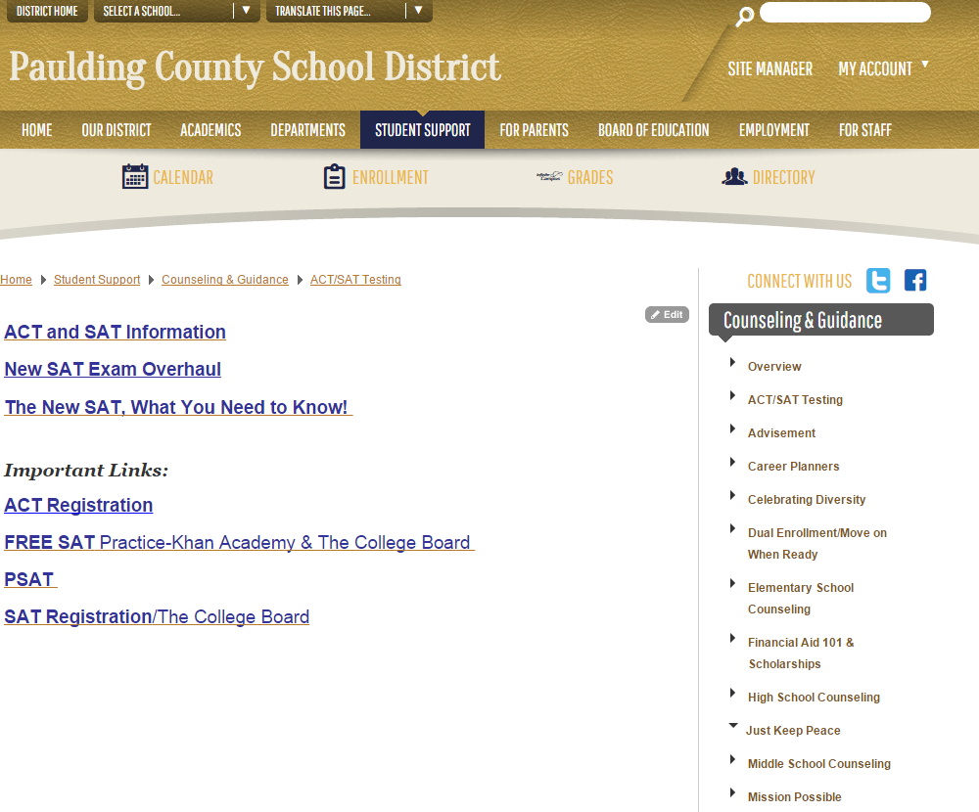

Sampling of Georgia schools' admission requirements based on SAT and/or ACT scores (remember these entrance exams are only one part of the admissions process and this can change from year to year):

Chattahoochee Tech | http://www.chattahoocheetech.edu/admissions/ | ACT, SAT, ASSET
Georgia Tech | www.gatech.edu | SAT CR* | 600-690
 |  | SAT Math | 650-730
Kennesaw State University | www.kennesaw.edu
University of Georgia | www.uga.edu | SAT CR | 560-650
 |  | SAT Math | 560-650
 |  | ACT  Composite | 24-29
University of West Georgia | www.uga.edu
*CR = Critical Reading

Comparison of the SAT and ACT Scores
Review your ACT composite score and your SAT I total score in the columns below. The score that is the highest on the ladder of either column is your best score. There are times when your score on one of the tests will be significantly higher than on the other. Colleges/universities use this scale or a similar ACT/SAT I (equivalency table) to compute your Best Score. Admission is based on these scores and your high school GPA in core classes. Always check with admissions offices, if you have a question about their policy on scores, class rank, or the calculation of GPAs.

There is a new redesigned SAT starting in 2016.

ACT | SAT
No order of difficulty | Proceeds in an order of difficulty
Score choice | No score choice
Grammar and reading emphasis | Vocabulary emphasis
Algebra, geometry and trigonometry | Algebra and geometry
Based on school curriculum | Not based on school curriculum
Not tricky and less distractions | Tends to be tricky
No guessing penalty | Guessing penalty
Science reasoning section | No science
English grammar tested | No English grammar
Scoring 0-36 points | Scoring 200-800 points
 | Note: SAT now as a writing test

Score Comparison Chart
-
ACT | SAT |  | ACT | SAT
36 | 1600 |  | 23 | 1060-1080
35 | 1560 |  | 22 | 1020-1050
34 | 1510-1550 |  | 21 | 980-1010
33 | 1460-1450 |  | 20 | 940-970
32 | 1410-1450 |  | 19 | 900-930
31 | 1360-1400 |  | 18 | 860-890
30 | 1320-1350 |  | 17 | 810-850
29 | 1280-1310 |  | 16 | 760-800
28 | 1240-1270 |  | 15 | 710-750
27 | 1170-1200 |  | 14 | 660-700
25 | 1130-1160 |  | 13 | 590-650
24 | 1090-1120 |  | 12 | 520-580


NCAA Clearinghouse Registration and Athletic Information

The National Collegiate Athletic Association (NCAA), an organization that has
established rules of eligibility, recruiting and financial aid, regulates most college athletic
programs. If you are planning to enroll in college as a freshman and you wish to
participate in Division I or II athletics, you must be certified and cleared by the NCAA
Initial Eligibility Clearinghouse.

Students who plan to participate in Division I or II college sports should go to the NCAA website for all pertinent information: (1) fill out NCAA Clearinghouse Release Form online, (2) check with their counselor, (3) mail the part of the form requested, (4) give part of the form with a transcript request to the registrar for him/her to mail to the Clearinghouse.

This form authorizes high schools to release your transcripts including grades, proof of graduation and other academic information to the Clearinghouse. It also authorizes the Clearinghouse to release this information to any colleges that may request it. Start the process early, preferable by the beginning of your senior year. The Clearinghouse requires 6 (six) semesters and your ACT or SAT score reports.

Students must request SAT or ACT scores be sent directly to individual colleges. Students should have score reports sent directly to the Clearinghouse by entering a special code on their ACT or SAT registration form.

This link is a valuable resource:
https://web1.ncaa.org/hsportal/exec/links?linksSubmit=ShowActiveLinks
Financial Aid Information

College is expensive, so seeking financial aid opportunities is important for everyone. It
is important to understand that scholarships and financial aid are often available for

students based on the following:
- Outstanding grades.
- Special talents.
- Special needs.
- Athletic ability.
- Focused career interests.
- Ethnicity or heritage.
- Leadership ability.

Applying for state and federal student aid is free! You begin by completing the (FAFSA) Free Application for Federal Student Aid that is available in the counselors’ office or career center. You can also find the FAFSA at www.fafsa.ed.gov. You can complete and file the FAFSA on line for quicker processing. Your answers are edited and transmitted with less room for error.

Financial Aid is most often based on need and this computes into a simple formula:

College Cost - Your Expected Family Contribution = YOUR FINANCIAL NEED

There are various types of financial assistance and it is important that you understand
the differences between them.
TYPES | BRIEF DESCRIPTION
Grants | Repayment is not required. Grants are given for athletics, academics,  special talent, need based, etc.
Scholarships | Repayment is not required. They are awarded based on athletics,  special talent(s), or academic excellence.
Loans | Must be repaid. Generally begin payment after education is stopped or completed. Student loans are available from federally sponsored or commercial institutions.  There are two types of student loans:  Federal loans that are guaranteed by the U.S. government  Alternative loans guaranteed by private agencies
Work Study | This program allows colleges to hire students for employment to pay  their own way as they attend college. The earned money does not have to be repaid.

Life$ense is a Financial Literacy Tool on GAfutures
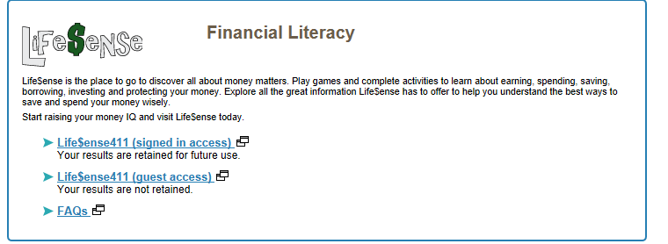

Budget Planning Worksheet
Complete a sheet for each college or technical school.

Income Source | Monthly Total | Yearly Total
Money from parents
Money from savings
Salary
Work-study
Scholarships
Grants
Loans
Spouse's Wages, if applicable
Other
Total Income
Expenses
Tuition
Fees
Loan interest payments
Book/supplies
Rent/housing
Gas/electricity
Telephone
Other
Childcare
Transportation
(gas, insurance, auto payment, parenting,
public transportation)
Food
Clothing
Entertainment
Medical/dental
Miscellaneous/personal
Total Expenses
Total Income Less Total Expenses
If your expenses are greater than your income, you'll need to look at options for reducing your expenses and/or supplementing your income.

HOPE PROGRAM OVERVIEW
https://www.gafutures.org/hope-state-aid-programs/hope-zell-miller-scholarships/
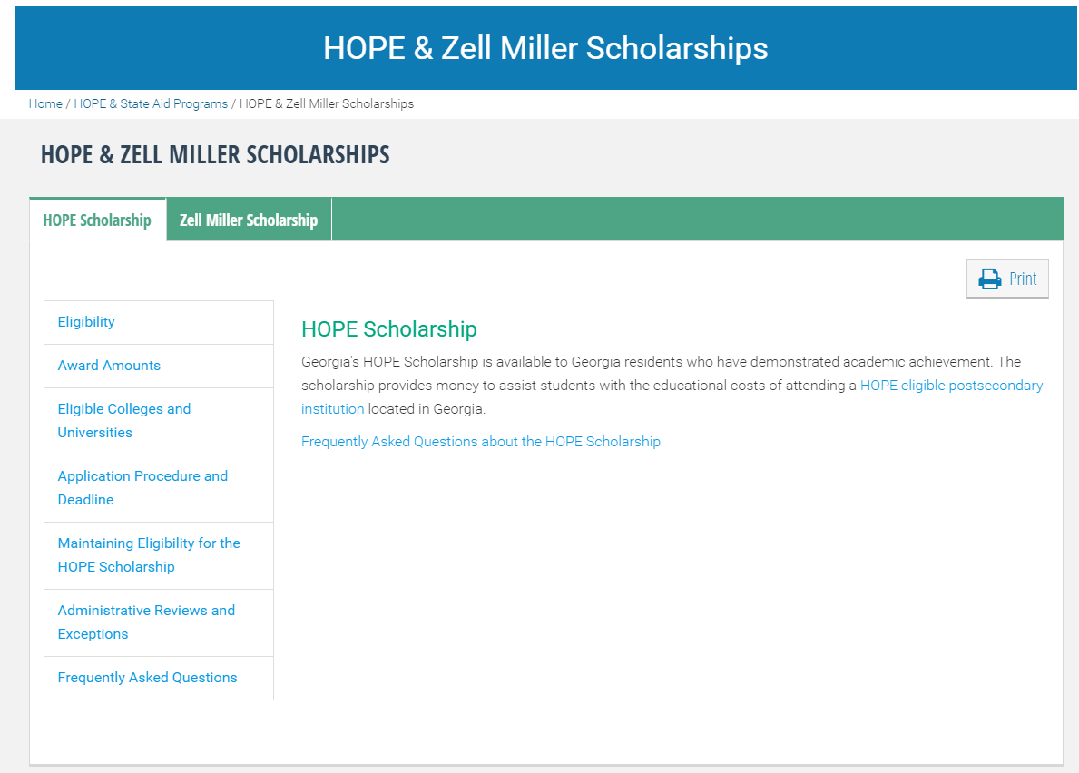

Zell Miller Scholarship Link: https://www.gafutures.org/hope-state-aid-programs/hope-zell-miller-scholarships/zell-miller-scholarship/

Important: ACT and/or SAT results must be from tests taken prior to the student’s graduation date. Test score results must go directly to Georgia Student Finance Commission from the testing service (ACT or The College Board).

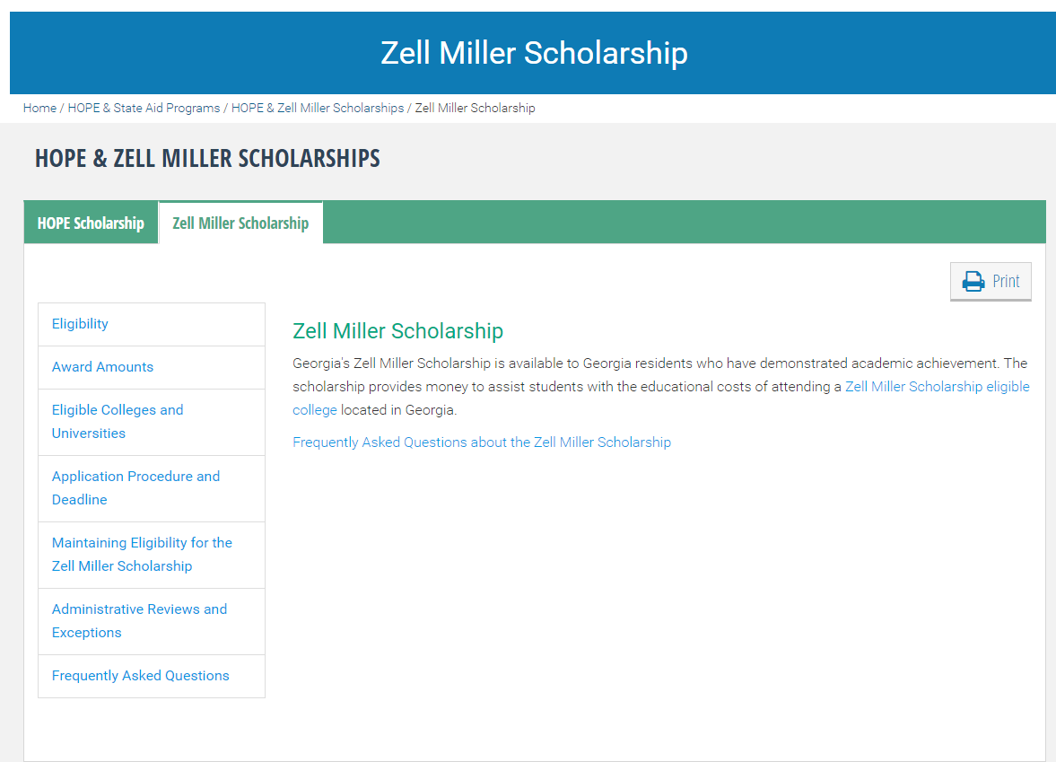

Explore Financial Aid 101 on GAfutures site:
https://www.gafutures.org/federal-aid-scholarships/

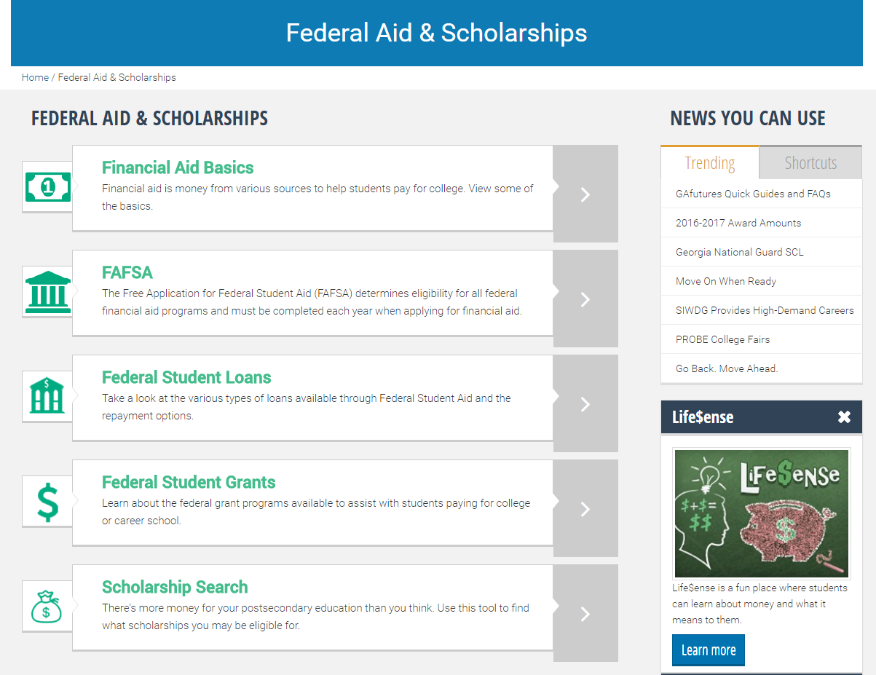

Employment/College Application Guidelines

Filling out an application is one of the most intimidating steps you can take when applying for a job or applying for admission to a college.

Do
- Use www.GAfutures.org for applications to schools in the state of Georgia.
- Always read applications and directions carefully before you begin.
- If making applications on line print out a copy for your records.
- Double check that everything that is supposed to be included is enclosed.
- Be honest about your accomplishments

Don’t
- Leave blank spaces. Missing information may cause your application to be discarded.
- Be unclear. If the question calls for a specific answer, don't try to dodge it by being vague.

FINDING THE JOB FOR YOU

Successful job hunting refers not only to finding a job, but also to finding the best job possible. When employment is plentiful this may not present a problem; but when jobs are scarce, you may have to think creatively and investigate many sources.

Listed below are suggested resources:
- Relatives, friends, and neighbors.
- Counselors, teachers.
- High school coordinators of career technical programs.
- Career centers.
- Help wanted ads and bulletin boards.
- Civil service, county, state, and federal agencies.
- Walk-in inquiries.
- Job fairs.
- Fellow employees.
- Contacts made through volunteer activities.

THE JOB APPLICATION

Even though many, if not most, applications are completed online today, the job application still contains a series of questions of a personal and work-related nature. Employers use the application as a device to screen applicants. You should take care that it makes a good first impression. The following are some suggestions for completing your application:
- Be careful. If you are careful about following instructions on your application, an
employer will think that you may be careful as an employee.
- Be neat. Key or print carefully so that your application can be read easily. Use a reliable blue or black pen, if the application is completed on paper.
- Be alert. If you are not sure about the meaning of abbreviations used on the form,
ask for clarification.
- Be complete. If a question does not apply to you, write, “Does not apply.”
- Be correct. Watch your spelling, grammar, and punctuation.
- Be inclusive. Describe all your skills and abilities. List the kinds of computers,
software programming, machinery, equipment, and tools you are able to use.
- Be accurate. Make sure all information is correct. Check employment dates,
telephone numbers, and addresses for accuracy.
- Be prepared. Take a resume with you when you apply for a job.
- By having all the information about yourself ready ahead of time, you will be able to
complete the application accurately. Include names, addresses, telephone numbers,
FAX numbers, e-mail addresses, dates, and supervisors' names.



Cover Letter

Most often today, a cover letter is done online as part of the application process.
You might think that if you have a good resume, you don't need a cover letter. Nothing could be further from the truth. The cover letter supplements the resume. It focuses attention on your achievements and gets a prospective employer interested in you. Cover letters are especially important to new graduates (either high school, technical school or college). You can persuade an employer to look past a possibly thin work history to see the value of your education and non-professional experience. A good cover letter contains the following elements:

Introductory paragraph: Keep this section short! Identify yourself and your objective.
You may also include how you came to hear about this opportunity. State the purpose of your letter in the first paragraph. Name the position you are applying for and how you heard of the opening.

Brief summary of your qualifications: Don't reiterate your resume.  Explain how the experiences or abilities listed in your resume related to the company's goals or to the duties of the position. Make a stronger impression by limiting your focus to one or two experiences. Be specific and try to include data as well as descriptions.

Conclusion: In the final paragraph, restate your interest in the company and provide information about the best time to contact you.

TEN TIPS TO GREAT COVER LETTERS:
1. Include important information. (e.g. your name, address and telephone number, email address and fax.)
2. Address your letter to a specific person within the company.
3. Make the opening sentence one that gets their attention.
4. Write a unique letter for each job/company.
5. Describe your talents/skills as they relate to the job.
6. Always type and proofread your cover letter before sending it out.
7. Use action words to describe your accomplishments.
8. Be confident, creative and enthusiastic.
9. Save a copy of every cover letter you send out.
10. Request a response by phone, letter or interview.

Sample cover letter for a college graduate

Date

Michael Personnel
Director of Employee Relations
Hallmark Cards, Inc.
1111 Powder Spring Road
Powder Springs, GA 30127

Dear Mr. Personnel,

Currently, I am a graduating senior at the University of Georgia. I am responding to your website advertisement for a marketing sales manager for Hallmark Cards, Inc. for the southeastern region.

As you can see from my attached resume, I have a degree in computer science and marketing from the University of Georgia. Although the bulk of my course work has been in computer science, I can assure you that I have excellent verbal and written communication skills. Additionally, I studied Spanish in high school and college and am fully bilingual.

My current position as an assistant store manager at Home Depot in Athens, Georgia, involves some writing, including bulletins and advertisements and strong organizational skills, which were stated as a need in your advertisement. I am familiar with desktop publishing software for Windows and for Mac.

I am eager to meet with you to discuss how my talents could be used to support sales in the southeast region for Hallmark Cards, Inc. I will email next Thursday to arrange an appointment. Thank you for your consideration of me for this marketing position.

Sincerely,

Your Name

(It is recommended that you use basic, common fonts, as well as nice stock paper in white or muted colors. Students are encouraged to use a header that states your contact information and attach a resume to the letter. When a website/online letter is created, you will always adhere to the directions on that website.)

The Resume
A resume is a brief description of your previous education, work experience, and additional relevant information. The purpose of a resume is:

- To introduce you to an employer.
- To serve as an example of how you think and express yourself.
- To catalogue skills, experience, training and achievements.
- To get you an interview!

The objective of the resume is to include:
- Name, address, city, state, zip, phone number with area code, e-mail address, fax number.
- Honors, awards, fellowships and scholarships.
- Licenses and certificates.
- Memberships and activities, including leadership positions.
- Special skills, such as computer knowledge and foreign languages.
- Job history listed with most recent job first (list even one part time position).
- Previous job experience to include: title of position, name and address of employer, beginning and ending dates, job description and responsibilities.
- Education with most recent or current school first; including degree, name of high school or college, address, major, and graduation date.

Presenting the information:
- Create an easy to read resume using quality paper stock, standard fonts, and dark type.
- Put most important information at the top of the page.
- Use only necessary words to present your information.
- Maintain a professional quality, but be creative.
- Use action verbs such as initiated, organized, maintained, designed, supervised and developed.
- Use past tense to describe former jobs and present tense to describe current jobs.
- Spell everything out. Do not use abbreviations or acronyms.
- Have someone proofread your resume.

Qualities of a good resume:
- Easy to read.
- Concise.
- Professional.
- Emphasize key points or expressions by using bold type or underline.

Mistakes to avoid:
- Too short, too long (preferred length is one page.)
- Misspellings, typographical errors, poor grammar.
- Irrelevant information – height, weight, gender, marital status.
- Disorganization.
- Too wordy and vague; important qualifications should stand out.
- Italics, underline, shadow or reverse type.
- Vertical and horizontal lines, graphics or boxes.

Sample Resume for a High School Student Who Has Just Graduated
This sample indicates the kind of information usually included in a resume. Sometimes post-secondary schools or employers will have their own special resume form that you will use, but the information that they all want is similar to what you see in this resume. You can make resume writing much easier by keeping accurate records of your accomplishments and saving copies of prior resumes.

YouKnow I. CanDoIt
100 College Station Road
Athens, GA 30007
Telephone: 770.289.6668

Objective:
Explain what you want to do, why you want to do it and how you plan to achieve your goal. “I intend to pursue a Bachelor of Science Degree with a double major in Computer Science and Marketing".

Education:
Paulding County High School 2014 - present. GPA 93.0%

Extracurricular Activities: Grade
Beta Club 11,12
Baseball Manager 10, 11, 12
Key Club 10, 11, 12 Vice President 11, 12
Spanish Club 9, 10, 11, 12 Vice-President 11, President 12

Community Activities:
Adopt-A-Grandparent (Church Group) 11, 12
Relay for Life (Beta Club) 11, 12

Honors and Awards:
National Honor Society Letter
National Spanish Honor Society Award
Straight "A" Award
Varsity Baseball Letter

Work Experience:
December, 2016 to Present Internship –Target

References:
Mrs. Jane Johnson, Counselor, Paulding County High School 770.443.8008
Rev. John Smith, St. Paul's Methodist Church 770.223.2424

THE INTERVIEW

Preparation
- Learn about the company/college and the
position. Check out their web site and request information from
the company's public relations department. Information that
can prove useful is the company's size, its history, the mai
products and services they provide, and current news stories. Know the story of the company or school.
- Double-check the time and location of the interview. If it is in an area that is new to you, get driving directions from yahoo.com or another reliable resource.
- Prepare what you want to say in the interview. Think about your greatest strengths and your most significant work or school experiences, your future plans and
your ideal job.
- Review your resume and think about how your experiences can be matched up with the job's requirements.

Interview Day
- Dress appropriately. Choose conservative clothing and keep jewelry and accessories to a minimum.
- Be punctual. Arrive a little early to allow yourself time to relax and focus.
- Bring extra copies of your resume.
- Be sure to listen actively throughout the interview.
- Make eye contact with interviewer(s).
- Give concrete examples when describing your work experience.
- Always be positive.
- Demonstrate that you have thought seriously about this career path and this company by asking intelligent question about the position.
- Ask your interviewers for their business cards to ensure that you have the proper contact information when you follow-up.

Some Typical Interview Questions:

- What can you tell me about yourself?
- What do you perceive to be your greatest strength?
- What are y our most important career accomplishments?
- What is the most difficult situation you have ever faced?
- What are your career goals?
- How do you cope with stressful situations?
- How do you see yourself working with others on the job?
- What are the things that motivate you?
- What do you value in a job?
- Why would you like to work for us?
- What do you want us to remember about you?

Questions to Ask the Interviewer:
- What is the potential for personal and professional growth opportunities within the company?
- What are the long-term goals for the company?
- What are the positive aspects of working for this company?
- What challenges would I face within this position?

When you leave the interview:
- Emphasize you are interested in taking the process to next step and why you are the ideal candidate.
- Shake hands, make sincere eye contact and say, “Thank you.”

The Follow-Up
- Send a follow-up letter or email. Thank the interviewer for taking the time to speak with you and let them know that you are still interested. Demonstrate your interest by describing how you could contribute to the company's future.
- Always review what you learned from the interview experience. What were the strongest parts of your interview? What were the weakest? Were you asked any questions you had not anticipated? What did you learn about this company or career track? Even if you didn't get the job, you can learn a lot from every interview.

Websites for High School Graduates

College Information

For Georgia Universities, colleges and technical schools go to www.GAfutures.org to link to all individual school websites.

College Resources

ACT | www.act.org
Colleges by State | www.mit.edu:8001/people/cdemello/univ.htm.
College Board | www.collegeboard.com
Campus Tours | www.campustours.com
COLLEGENET | www.collegenet.com
College Parents of America | www.collegeparents.org
CollegeXpress | www.collegeexpress.com
College Search | http://apps.collegeboard.com/search/index.jsp
GAfutures | www.GAfutures.org
NACAC for parents and students | www.nacac.cACAom/p&s.html
NCAA Eligibility Guide | www.ncaa.org/eligibility/cbsa
Peterson's Guide to Colleges and Universities | www.peterson.com

Career Information

America's Job Bank | www.ajb.dni.us
Career Browser | www.collegeboard.com
Career Interest Game | http://career.missouri.edu/holland
Career Paths | www.careerpathsonline.com
Fedworld.gov | www.fedworld.gov
GAfutures | www.GAfutures.org
Job Board | www.collegeJobBoard.com
Job Hunter's Bible | www.jobhuntersbible.com
Military Career Center | www.militarycareers.com
Occupational Outlook Handbook | www.umsl.edu/services/govdocs/ooh200022001/1.htm
Planning a Career | www.adventruesineducaton.org
Resumania | www.resumania.com
The Career Key | www.careerkey.org
The Keirsey Temperment Sorter | www.keirsey.com/frame.html
University Career Centers | www.careerresource.net

Scholarship/Financial Aid Information

College Aid | www.collegeaid.net
Direct Loan (Gov) | www.ed.gov/offices/OPE/DirectLoan
E-HOPE  APPLICATION | https://www.gsfc.org/Hope/Secure/dsp_eapp_login.cfm?act=pb
FAFSA | www.fafsa.ed.gov
FAFSA Express | www.ed.gov/offices/OSFAP/students/apply/fexpress
FastWeb | www.fastweb.com
Financial Aide  (Georgia Student  Finance Commission | www.gsfc.org
Financial Aid  Estimator | www.finaid.org/calculators/finaidestimate.phtml
Financial Aid Tips  from NASFAA | www.nasfaa.org/Home.asp
HOPE Scholarship | www.fafsa.gov
Horace Mann  Scholarhips | www.horacemann.com

Study Skills and Testing

ACT | www.act.org
AP Exam Review | www.apexlearning.com
Calculus@internet | www.calculus
College Admission  Testing | www.kaplan.com/precoll
College Board  Online | www.collegeboard.org
Study Skill Sites | www.ucc.vt.edu
 | www.studyweb.com
 | www.dartmouth.edu/admin/acsills/index.html
 | www.d.umn.edu/student
 | www.ucs.umn.edu/lasc/onlinelearn.html


Glossary of Terms

Acceptance
Candidate is in; most colleges notify students by April/May.
Student needs to reply if he or she will not attend college.

Accreditation
Recognition of a college or university by any of the regional or national accrediting bodies indicating that the institution is meeting its objectives.

ACT
A college entrance achievement examination that is a predictor for college success. It is required or recommended by many colleges as part of the admission process. The ACT measures educational development in English, Mathematics, Reading, and Science.

Advanced Placement
Granting of credit and/or assignment to an advanced course on the basis of evidence that the student has mastered the equivalent of an introductory course. High schools implement the courses and administer the exams. Check with admissions office regarding acceptance for college credit.

Apprenticeship Programs
During this process, the worker (apprentice) learns an occupation in a structured program sponsored jointly by employers and labor unions or operated by employers and employer associations.

Associate Degree
A degree granted after the satisfactory completion of a two-year full time program of study or its part time equivalent. In general, the Associate of Arts (AA) or Associate of Science (AS) degree is granted after completing a program of study similar to the first two years of a four-year college curriculum. In Georgia most of the CORE curriculum can be earned at a two year school and transferred to a four year school. Check with admissions office.

ASVAB
This test shows your skills or various strong points that you may have in order for you to have a more successful life. This test is also given to determine people's ability to learn certain skills needed for every day life. This test is required for a career in the military. It is administered in high schools at no charge. Results of the test are discussed with students.

Bachelor's Degree
A degree received after the satisfactory completion of a four or five year full-time program of study at a college or university.

BRIDGE Graduation Plan
A state-mandated advisement opportunity that includes counseling support regarding academic and career decisions. A plan is developed to meet long-term career goals.

Career-Oriented Program
A group of courses, which prepares students primarily for employment, often in a specific occupation. Such a program, which can last a few months or more than two years, may lead to a certificate, diploma, or associate degree.

College Entrance Exams
Tests that are used by colleges and universities for evaluation of
applicants for admission or for placement in courses. Tests used most frequently are the ACT
and the SAT I & II. Note: There is now a SAT writing test that must be taken.

College Transfer Courses
Courses that transfer as college credit to bachelor's degree programs elsewhere. Most times in the state of Georgia, these are referred to as CORE courses.

Cooperative Work-Study Education
A program through which some colleges grant course credit based on results of ACT scores or SAT Achievement scores, the ACT Proficiency Examination Program (PEP), the College Entry Examination Board (CEEB), the College-Level Examination Program (CLEP), or other examinations.

Credit Hour
A unit of measure for course work. An average college class is 3 or 4 credit hours. To receive credits usually the student would attend about 15 weeks and therefore, would attend class for approximately 45 clock hours. An average semester load is 14-18 hours with 4-6 courses. Twelve hours is considered to be a full time student.

Deferred Admission
The practice of some colleges of allowing an accepted student to postpone enrollment for one year.

Early Action
First-year applicants for a college or university may have the option of submitting a completed application in the fall of the senior year by a set deadline. For example, the University of Georgia has a fall deadline of October 15 of their senior year. Then, the college/university receives an admission decision by the senior by an early decision deadline set by the post secondary school. Of course, primary consideration under the Early Action plan is focused on demonstrated academic achievement/grades in core academic courses through the junior year, rigor of curriculum and performance on the SAT I or ACT with Writing.
Early Decision
Under early action, you follow an accelerated application process and apply by early October. Students are notified of a decision by mid-December; if accepted, students do not have to inform the institution of their decision until May 1. An example is UGA.

Federal Pell Grant
Financial assistance, awarded by the federal government to undergraduate students on the basis of need. The grant may be used toward tuition, room and board, books or other educational costs. This money does not have to be repaid.

Federal Work Study
A federal financial aid program providing on and off campus work for college students.

Financial Aid Form (FAF)
A form, which is required by some colleges as a supplement to the FAFSA. This is to be completed by the student and his/her parents.

Free Application for Federal Student Aid (FAFSA)
The starting point in applying for financial aid in which information about the students total family income, assets and expenses, and analysis of the family's potential contribution toward college expenses is collected.

GAfutures
A website giving information regarding postsecondary schools in Georgia that are eligible for state-funded student financial aid - a network of public and private universities and colleges, public technical colleges, and special purpose schools located throughout the state. This site is also used for students who take advantage of Move on When Ready courses. A student’s HOPE GPA may be reviewed on this site. The site also contains information regarding Financial Aid. A student can use this site to apply to postsecondary schools in Georgia.

Georgia Career Information System
This website is used by all high school students to meet the BRIDGE advisement requirements. The Georgia Career Information Center operates the Georgia Career Information System (GCIS). Working with educational and labor market professionals, GCIS contains assessments, explorations, and search strategies as well as the most comprehensive and accurate state and national occupational and educational information.

Grade Point Average (GPA)
An indicator of the student's overall scholastic performance. The Paulding County School District reports GPA on a numeric basis. For example a student may have a 92.2 overall GPA. Colleges often compute the GPA totaling the number of grade points earned in each course (generally, A=4,
B=3, C=2, D=I, F=O) and then dividing the sum by the total number of credit courses carried. For HOPE, only CORE courses count when calculating the GPA for college entrance.

Honors Program
Any program offering opportunity for superior students to enrich their educational experience through independent advanced or accelerated study. Most major four year colleges and universities offer honors programs.

Independent Study (College Level)
An arrangement which allows the student to earn college credit through individual study, usually planned with and supervised by a faculty advisor.

Internships
Opportunities for "hands on" experience. Some for pay or as a volunteer.

Job Shadowing
A process whereby students are taken to a place of business and allowed to
observe the employees going about their daily work. Shadowing is a relatively short unpaid
experience. It can be only a few hours in length or it can extend over a few days.

Letters of Recommendation
Letters that student’s request of teachers, parents, friends, counselors, employers, etc. to support their applications for college admission and/or scholarships and employment. Most out-of-state colleges and universities require some form of recommendation (either a letter or a rating sheet.) Be considerate. Give the person at least two weeks to write a letter for you.

Loans
Monies borrowed that must be repaid along with interest.

Major
The subject of study in which the student chooses to specialize and pursue in college; a
series of related courses, taken primarily in the junior or senior years of college. This may be in
any number of subject areas or fields. Scholarships are often associated with majors.

Master of Arts or Science Degree
A degree awarded after completion of a BA or BS degree, usually needs 30-45 college hours beyond the bachelor's degree.

Mentorship
Working with a student on a one-to-one basis. Mentors typically dedicate a few hours each month to familiarize their student with the workplace, offer insight on basic skills needed, or assist with school projects and personnel issues.

Minor
A secondary subject of study the student chooses to specialize and pursue in college.

NCAA (National Collegiate Athletic Association)
If you are planning to enroll in college as a freshman and you wish to participate in Division I or II intercollegiate athletics, your initial eligibility status must be determined by the NCAA Clearinghouse. You should apply for certification after your junior year in high school.

NCAA Student Release Form
This form authorizes high schools to release student transcripts - including grades, proof of graduation, and other academic information to the Clearinghouse. It also authorizes the Clearinghouse to release this information to the colleges that request it.

Non-Traditional Career
Occupations that require working in a field that has been traditionally dominated by 70% of the other gender. These jobs usually require post-secondary vocational or technical training. These jobs break the stereotypes of "men's work" and "women's work'.

Open Admissions
The policy of some colleges of admitting virtually all high school graduates, regardless of academic qualifications such as high school grades and admission test scores. Many two year colleges have open admissions.

Orientation
During the summer college and technical schools typically provide an orientation program. You and your parents will be invited on campus to learn the layout of the campus and pre-register for your courses. Be certain to take advantage of this opportunity.

Portfolio
A collection of work that documents a students educational performance and employment experiences over a range of time. Portfolio files are a collection of the best examples of a student's work.
Oftentimes students who major in areas like graphic design have a portfolio of their work.

Preliminary Scholastic Aptitude Test (PSAT)
A program designed to provide a practice test for juniors as a warm-up and preparation for the SAT. In the state of Georgia, students take this test their sophomore year and may take the test again during their junior year. This test is given in October.

Rank
A student's standing in his/her high school graduating class. Rank is based on grade point average and is expressed in percentiles or rank order.

Requirements
For a university, you must meet three requirements for graduation: one for the university, one for the college and one for the department. Always seek guidance from the college catalog and your advisor.

Resident Advisor
An older student who lives on your floor or hall in the dorm and helps with any living situation or problems that might arise.

Reserve Officers Training Corps (ROTC)
Air Force, Army and Navy programs on certain campuses which combine military education with baccalaureate degree study.

Resume
An outline of your life from grades 9-12. It should contain important information about you, which will paint a picture for admissions and scholarship committees as well as for employers. Resumes are also created for the world of work when you are getting ready to apply and interview for a job.

SAT
Achievement test of verbal, mathematical skills and writing skills, which are given at specified test
centers throughout the year. Required or recommended by colleges as part of the admission
process as it is considered a predictor of college success.

Scholarship
A merit-based award for students with outstanding achievements; students with high grades and ACT or SAT scores; athletes; musicians; artists, etc. Many scholarships are available from corporations, community agencies, civic and military associations, and more. The competition for them is rigorous.

Study Time
As a general rule in college courses, for every one hour in class you will need to spend two hours outside of class studying.

Syllabus
Comprehensive information given out by college professors and includes assignments, grading policy, attendance, policy, course objectives, etc.

Two Year Colleges
Regionally accredited, post-secondary institutions at which the associate degree is the highest credential awarded. They offer comprehensive, technical, transfer, and continuing education or specialized curriculums.

Transcript
Official record of high school or college courses, GPA and class rank. Required as part of the college application process.

Work Experience Program
Offers all students and Special Education students the opportunity to receive on-the-job training during the school day.

BRIDGE ADVISEMENT AND CAREER PLANNING

BRIDGE Advisement is mandated advisement and by law students in grades 6-12 must complete certain advisement tasks each year. Students, along with their parents/guardians make plans and career decisions throughout middle and high school. This law supports the district counseling motto which is MISSION POSSIBLE: Graduation and Beyond. Professional school counselors support all students in the advisement process to meet career goals beyond high school. The following information provides you with the BRIDGE ADVISEMENT CHECKLIST/TASKS for grades 6-12 (Using GCIS). Students will use the IC Portal to review both their MYAP Tool Individual Graduation Plan and any work that has previously been completed in GCIS.

6th Grade-Account Set-up and the Career Cluster Interest Inventory
Students take one of the Career Cluster Interest Inventory on GCIS.
___________________________________________________________

7th Grade
Reality Interest Inventory and Exploration of 3 Career Concentrations/Clusters through the use of the YouScience snapshot assessment.
___________________________________________________________

8th Grade
Students explore and research 3 careers. The BRIDGE Advisement Graduation Plan is completed and then, the IGP under the MYAP Tool in IC is used to update the students’ Individual Graduation Plan/Plan of Study.
Students are provided with Dual Enrollment/MOWR information.
___________________________________________________________

BRIDGE Advisement “Individual Graduation Plan”
High School Students Complete Their IGP in Infinite Campus
 | 9th Grade | 10th Grade | 11th Grade | 12th Grade | Total Units
English/
Language Arts
Math
Social Studies
Science
Health
Physical Education
CTAE
World Language
Fine Arts
Electives

4-year Total: _____

9th Grade
Students investigate further the 3 careers selected during 8th grade or may review and research three additional careers/occupations in the career interest area(s).
They also update the BRIDGE Advisement Plan and IGP in IC using the MYAP Tool and are provided Dual Enrollment Move on When Ready information.
___________________________________________________________

10th Grade
Students update the BRIDGE Advisement Plan and IGP in IC.
10th grade students receive Dual Enrollment Move on When Ready information. In addition, tenth grade students take the YouScience Assessment, an ability and interest inventory.

11th Grade
Students explore and save 3 postsecondary institutions that support the BRIDGE Advisement Graduation Plan. Students once again update the BRIDGE Advisement Plan and IGP in IC and receive information regarding Dual Enrollment. Students will also explore workforce initiatives in advisement.
___________________________________________________________

12th Grade
During August or September of the senior year, district 12th grade students and parents understand and review both pages of the Senior Letter. In addition, students use GCIS to identify the “next step” after high school graduation which may be a 2 or 4 year college, technical college, military, specialize school, apprenticeship or work.
___________________________________________________________

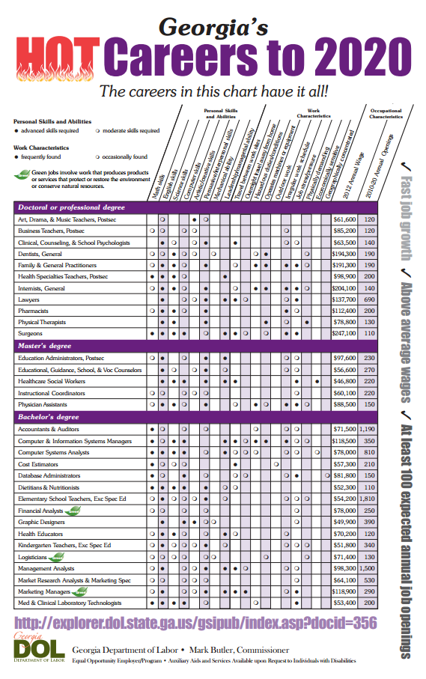
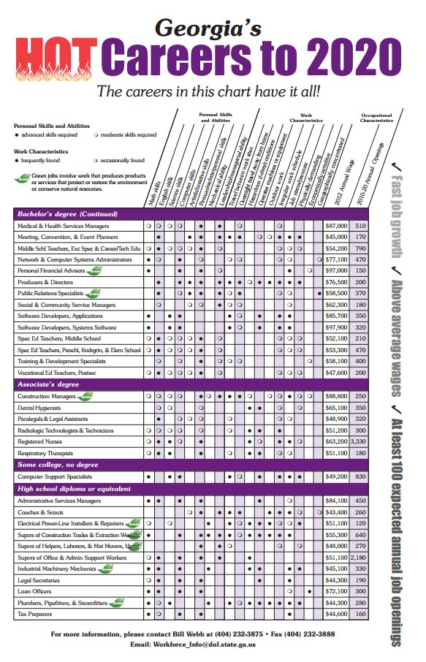



Remember it is normal to feel confused and unsure. When you have questions and just need someone to help you find your way, please make an appointment with your school counselor.

